Engleski jezik II121 18.5.

-Upute:

- Lekcija *Olympic news: review race*

- Pročitati lekciju ispod, te izdvojiti i prevesti nepoznate riječi.

- Riječi pisati u bilježnicu, možete se koristiti online rječnicima.

**Olympic news: review race**

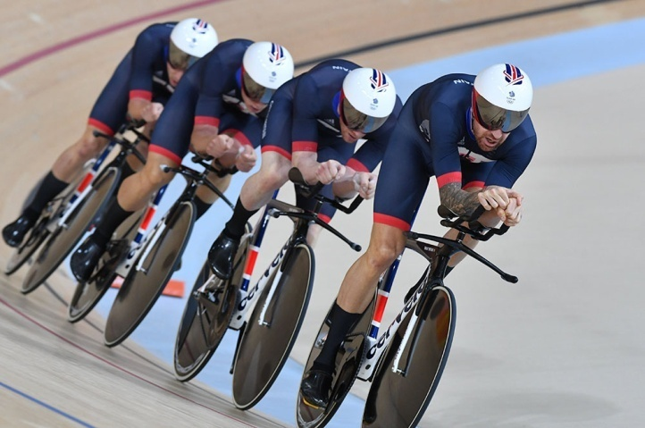**Olympic Games, 2020**  
**Location:** Tokyo  
**Dates:** July 24 – August 9, 2020

The cycling calendar is usually quite a fixed affair, with the same races appearing every season generally in the same familiar slot. But every four years a spanner gets thrown in the works in the form of the Olympic Games.

2020 is, of course, one of those years, and between July 24 and August 9 this year the world’s best riders will convene in Tokyo in the hope of adding an Olympic medal to their palmares.

The Olympic games include road, track, mountain bike and BMX events.

**Road events**

The most comparable annual race on the road calendar to the Olympic road race is the World Championships. Both events feature a circuit-based road race and lengthy [time-trial](http://www.cyclingweekly.co.uk/news/racing/olympics/uci-confirm-rio-2016-olympic-road-race-time-trial-courses-148721), and in both events riders compete for their nation rather than their trade team.

Unlike the Worlds and most other races, where failure one year is at least compensated by the chance to try again in 12 months’ time, riders only get a few shots at winning an Olympic medal throughout their entire careers, and consequently the event attracts stellar fields.

In Tokyo, the men’s road race will take place on Saturday, July 25. The women’s road race follows on Sunday, July 26.

On Wednesday July 29, both men and women will race their respective individual time trials.

**Track events**

Following the road events will be six days of track cycling within the Izu Velodrome, from Monday August 3 to Sunday August 9.

Riders will contest the team pursuit, omnium, sprint, team sprint and – newly added for 2020 – he madison.

The omnium features a revised format, with four endurance events (scratch, elimination, tempo and points race) included over one day of competition, as opposed to the previous two days which also included a flying lap, time trial, and individual pursuit.